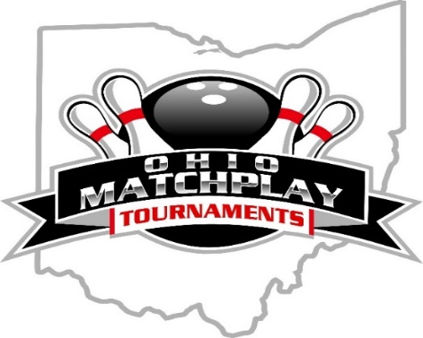

**OHIO MATCHPLAY TOURNAMENTS**

**presents**

**4th Annual Qubica Classic**

**50 & Over Bowling Tournament**

***Saturday* – January 25,2025 @ 1 pm.**

**(check-in starts at 11:30 am)**

**Columbus Square Bowling Palace**

5707 Forest Hills Blvd – Columbus, OH. 43231

**1st Place in this event is $1100\***

**\*Based on 48 Entries**

1:4 Payout Ratio

(Jackpots, Brackets, Eliminators + 50/50 Raffle)

**Entry Fee: $110.00 payable at check-in.**

**($75-prize fund, $25-lineage/expenses, $10-year end)**

* Tournament is open to USBC sanctioned adult men & women over the age of 50.
* Walk-in entries are accepted the day of the event.
* All scores are scratch, no handicap.
* FORMAT: 5 Qualifying games across ten lanes while moving pairs after each game. The pattern is OMT-40.
* Finals will be seeded two game matches in a bracket type format.
* 1:4 cash ratio. High 60 and over player outside of the cut will receive their entry fee back courtesy of Tom Carter’s Pro Shop.
* A copy of the complete rules is available at the check-in table. For any other scenarios, then USBC rules will apply.
* Reserve your spot by contacting Dennis Haines at 614-586-6682 or Mike Craig 614.563.2593.

*For questions or information please contact:*

Dennis Haines 614.586.6682 or Mike Craig 614.563.2593

Join or like us on FACEBOOK: <https://www.facebook.com/groups/ohiomatchplay>.

****